Fal Energy Partnership | A cooperatively-run local social enterprise. Supporting community-owned renewable, and energy use that’s fairer for people and planet | 
Homepage: | https://www.falenergy.co.uk/ | 
Membership: | https://www.falenergy.co.uk/membership/ | 
Community Energy Plus | Local energy advice and support.  Check out their online guide and home visits from their low carbon energy advice network | 
Homepage: | https://cep.org.uk/ | 
Home visits: | https://cep.org.uk/information-pages/free-retrofit-home-visit/ | 
Greenpeace Falmouth | Local groups forming an international movement of people who care deeply about climate, nature and justice | 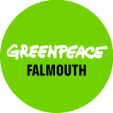
Local group link: | https://greenwire.greenpeace.org.uk/s/groups | 
Transition Falmouth | Community environmental and social movement.  Check out their local circular economy and food guides, and info on hard to recycle materials | 
Homepage: | https://www.transitionfalmouth.org.uk/ | 
Join the mailing list: | https://www.transitionfalmouth.org.uk/contact-us/ | 
Resilience Web | Check out all these local groups and more at the Penryn and Falmouth Resilience Web, or join the Community Alive Falmouth mailing list | 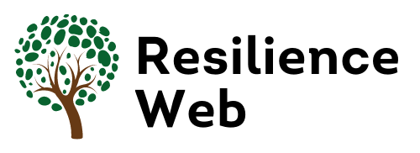
Homepage: | https://falmouth-and-penryn.resilienceweb.org.uk/ | 
Join the mailing list: | https://falmouthalive.org.uk/contact-us/ | 

